MMC Meeting
November 8, 2023
8:00am – 2:00pm
Wis Rapids

Agenda topic for MMC: Bayfield County, Cheri Deragon –
- Reclassify unit 396, class code 925 as class code 640 pre-wet brine. They want to be able to use this unit in winter (640) and in summer as class code 925.
- Pre-wet configuration is mounted on truck unit 36, which is a class code 106 with a mounted underbody plow qualifying for winter readiness reimbursement.
- Questions –
  - Can the classification as 640 be used in winter and summer charging at $31.25/hour?
  - Or update the classification for summer to 925 at a rate of $15.74?
- Risk: Multiple updates between winter and summer there is the risk that County doesn’t update to 925 and is charging use at the 640 higher rate or reverse is true.
- Recommendation: Class as a 640 and don’t update the class code between winter and summer use.

Pictures:
- Unit 36 – Class Code 106 Truck
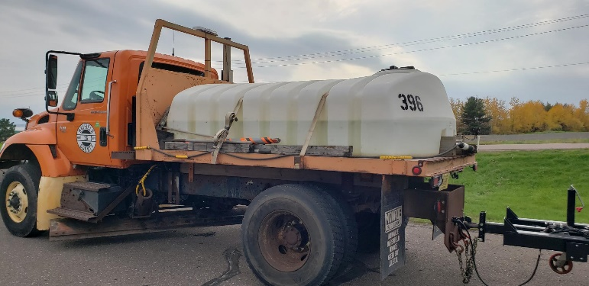

- Unit 396 – Class Code 925 (water tank/spray bar/pump)

