University of wisconsin Pesticide Applicator Training and WIsconsin Department of Agriculture certification testing

This training provides educational material and certification for employees to become certified in pesticide applications. The training will consist of a 3-hour review by UW-Extension and a certification test administered by the WI Department of Agriculture. The certification will be honored for 5 years.
333
2 Sessions, 8:00 AM to 3:00 pM
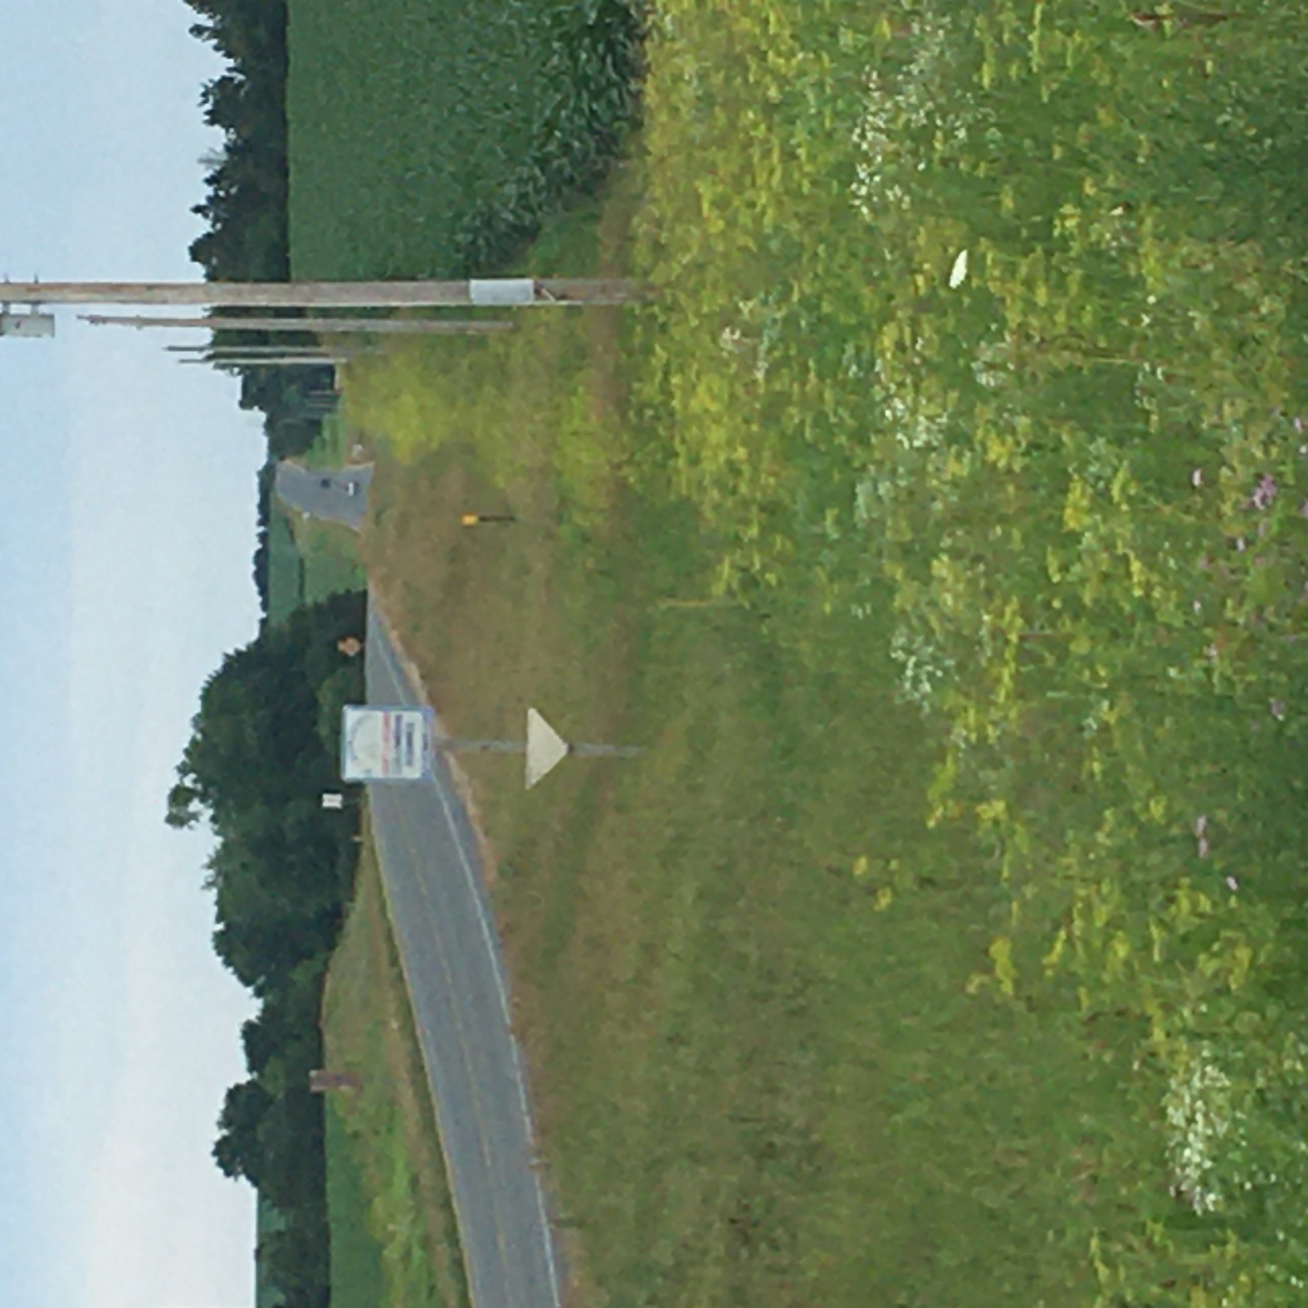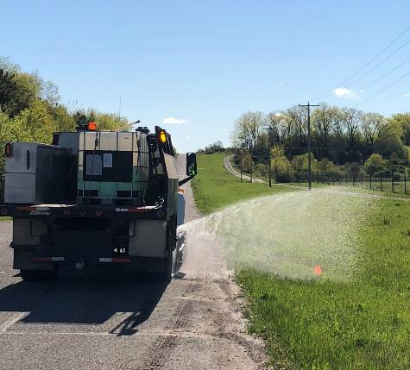See attached registration form.
Gary Kennedy
WCHA Prof. Development Director
1355 N. 16th Street
Manitowoc, WI 54220
hwygaryk@gmail.com

April 20, 2023
Waukesha County Department of Public Works
1641 Woodburn Rd, Waukesha, WI 53188

April 27, 2023

Waupaca County Highway Department
2670 County Road A, Waupaca, WI 54981

*Registration fee $181 per person –
Includes manual, training, and certification

Sponsored by: WCHA, UW Madison, and
WI Department of Agriculture

